Name: _______________________________________________
Foundation Unit 20 topic test
Date:
Time: 35 minutes
Total marks available: 29
Total marks achieved: ______

Questions
Q1.
Solve the simultaneous equations
4x + y = 25
x − 3y = 16
x =...........................................................

y =...........................................................
(Total for Question is 3 marks)

Q2.
Solve the simultaneous equations
3x + 2y = 4
4x + 5y = 17

x ...........................................................
y ...........................................................
(Total for Question is 4 marks)
Q3.
A cinema sells adult tickets and child tickets.
The total cost of 3 adult tickets and 1 child ticket is £30
The total cost of 1 adult ticket and 3 child tickets is £22
Work out the cost of an adult ticket and the cost of a child ticket.
adult ticket £...........................................................
child ticket £...........................................................
(Total for question = 4 marks)

Q4.
On the grid, draw the graph of y = for values of x from 1 to 7
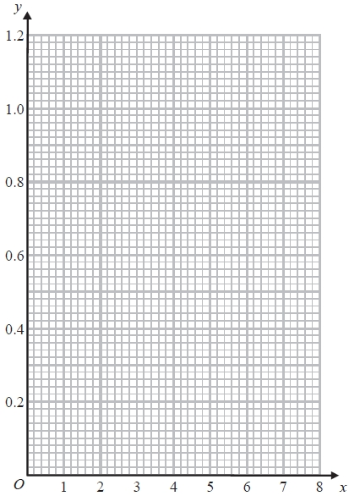

(Total for question = 3 marks)

Q5.
Make t the subject of the formula
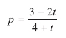

..............................................................................................................................................
(Total for Question is 4 marks)

Q6.
Make m the subject of the formula 6m² = k

m = . . . . . . . . . . . . . . . . . . . . . .
(Total for Question is 2 marks)

Q7.
(a) Complete the table of values for y =
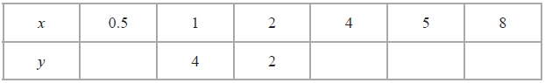
(2)
(b) On the grid, draw the graph of y = for 0.5 ≤ x ≤ 8
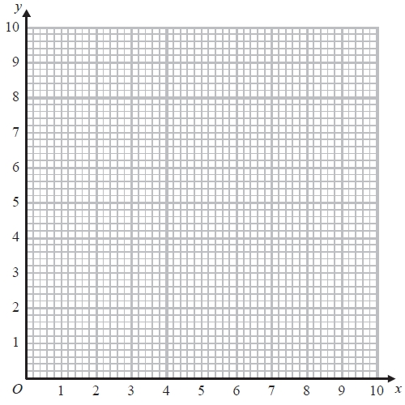
(2)
(Total for Question is 4 marks)
Q8.
(a) Complete the table of values for y = ⁶⁄x
x | 0.5 | 1 | 2 | 3 | 4 | 5 | 6
y |  | 6 | 3 |  | 1.5 |  | 1
(2)
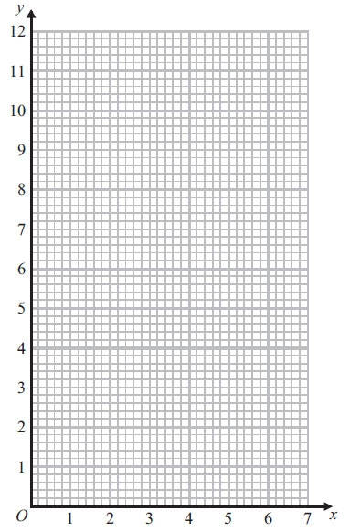
(b) On the grid, draw the graph of y = ⁶⁄_{x} for 0.5 ≤ x ≤ 6
(2)
(Total for Question is 4 marks)

Q9.
(a) Complete the table of values for y = x³ − 4x
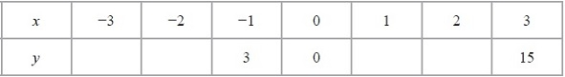
(2)
(b) On the grid, draw the graph of y = x³ − 4x from x = −3 to x = 3
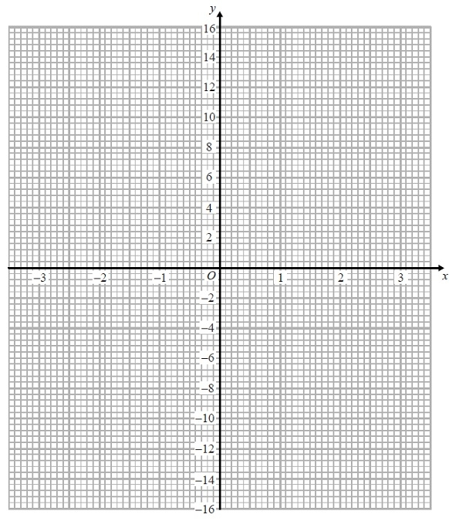
(2)
(Total for Question is 4 marks)

Examiner's Report
Q1.
This was a standard simultaneous equation question which was, for some candidates a single step to eliminate one of the variables. Most candidates who had an idea of what to do multiplied the first equation by 3 and added. Those that subtracted were not awarded any marks. Others multiplied the second equation by 4 and subtracted. Those that added were not awarded any marks. In fact, elimination rather than substitution was the overwhelmingly commonly seen approach. Often, the elimination was carried out incorrectly with the difference between 12x and – x being found as 11x, for example. Once again, arithmetical weakness meant that candidates were losing marks. Typical errors included:
• Getting to 13x = 91 and failing to go any further
• Working out the difference between 64 and 25 and getting 41It was a pleasure to see some candidates properly checking their solution.

Q2.
There were many instances where arithmetic errors spoilt otherwise sound method. Rearrangement usually led to error, but there were very few trial and improvement approaches. The elimination method was used by nearly all candidates, though 7x = 14 was the common error.

Q3.
Only a minority of students chose to derive a set of simultaneous equations to solve. The majority of students used a trial and improvement approach to the solution, which could only be credited on giving the correct answers. Common incorrect answers scoring 0 marks were £7.50 (from 30÷4) and £5.50 (from 22÷4).

Q4.
Many students made a good attempt to draw the graph and most of the work seen was accurate. The most common error was to calculate and use the value of the function at x = 3 to be 0.3. An answer using 0.3 was not appropriate as the grid allowed more accuracy than one decimal place in the plotting of values. Graphs including the point (3, 0.3) could therefore not be awarded full marks.

Q5.
This question was poorly completed, with few candidates managing to gain more than one mark for an intention to multiply through by 4 + t. Often the bracket was missing and p(4 + t) became 4p + t. Candidates did appear to realise that they needed to find 't = something' but lacked the ability to achieve this. Of those who did successfully isolate the term sin t, only the most able went on to factorise correctly.

Q6.
It was nice to see the occasional ± to give a fully complete answer. Many candidates, however, interpreted 6m² as (6m)² and ended up with m = 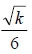. Some candidates were not careful enough with the placing of the square root sign so it was difficult to distinguish m = from m =

Q7.
In part (a), many students were able to score at least 1 mark for working out 2 or more values in the table. Common errors were to work out 4 ÷ 0.5 as 2 and/or 4 ÷ 8 as 2.
In part (b), most students, having scored at least 1 mark in part (a), were then able to score a mark for correctly plotting 5 or 6 points from their table. A common error here was to join the points with straight line segments rather than with a smooth curve.

Q8.
Part (a) was well done by the majority of candidates. However, there were a significant number of candidates who made no attempt to complete the table.
Most candidates who completed the table went onto score at least one mark in part (b). Common errors were (0.5, 3) and (5, 1.25). There continues to be a number of candidates who plot the points from the table and then just leave the graph as a series of plotted points rather than attempting to draw a smooth curve. Some candidates did join their points but with straight line segments rather than a smooth curve.
One fairly common incorrect response was to plot all of the points but only join the points from (1, 6) to (6, 1), not from (0.5, 12).

Q9.
Many correct answers to this question. The only common error in completing the table was use of 15 instead of −15. Plotting was good, though an opportunity to correct errors in the table were lost due to the failure to anticipate the correct shape of the graph. There were many errors in joining the points, with many using straight line segments or curves which missed joining the points.

Mark Scheme
Q1.
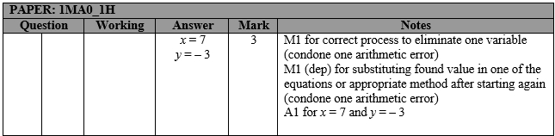

Q2.
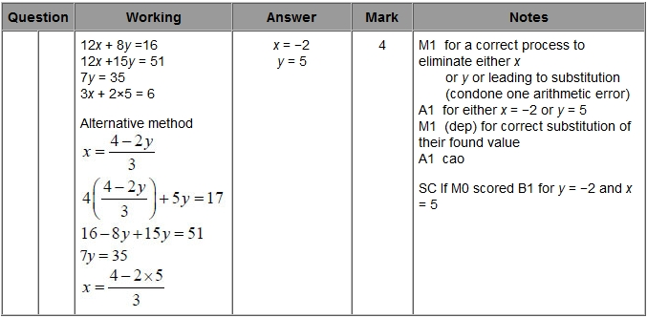

Q3.
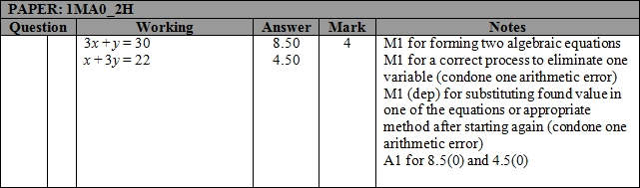

Q4.
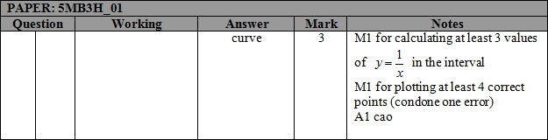

Q5.
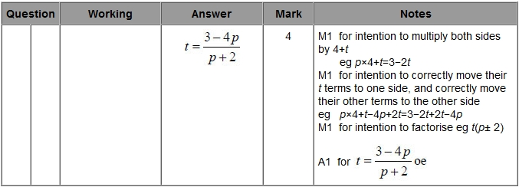

Q6.
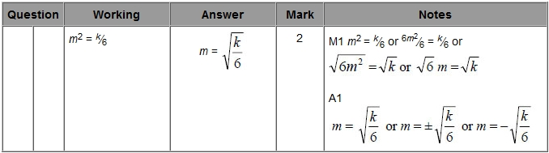

Q7.
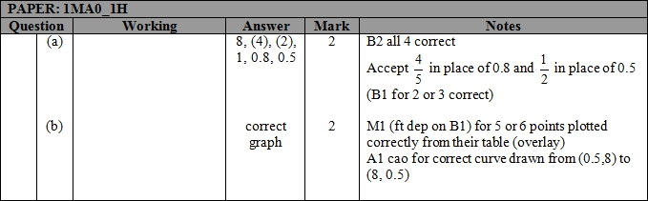

Q8.
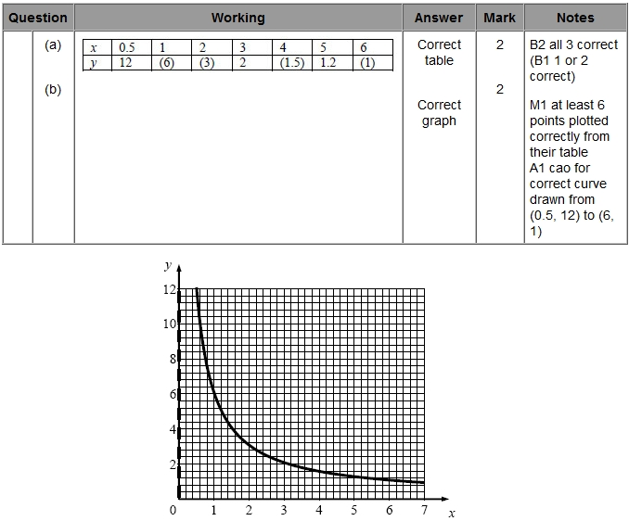

Q9.
